**Directions to the USF CSD Hearing and Speech-Language Clinics**

**\*\*Please do not use the mailing address: ~~4202 Fowler Ave.~~**

**Building Address: 3711 USF Laurel Dr, Tampa, FL 33612**

**From I-275** (Downtown Tampa or Airport Area)

* Exit I-275 to Fletcher Avenue (exit 52)
* Drive east on Fletcher Avenue, past Bruce B. Downs Blvd. to Magnolia Drive
* Turn right on Magnolia Drive and drive south
* Turn left at 2nd traffic light onto Citrus Drive - opposite Moffitt Cancer Center
* Turn right at the traffic circle onto Laurel Drive-building is on the right side look for the sign for 3711 CSD. Parking Directions are on next page.

**From I-75** (from Areas North, South, or East of Tampa)

* Take Fletcher Avenue (exit 266) and drive west to Magnolia Drive
* Turn left on Magnolia Drive (at light) and drive south
* Turn left at 2nd traffic light, Citrus Drive - opposite Moffitt Cancer Center
* Turn right at the traffic circle onto Laurel Drive-building is on the right side look for the sign for 3711 CSD. Parking Directions are on next page.

**Fowler Avenue Entrance**

* Turn onto Leroy Collins Blvd. into USF campus main entrance
* Turn left at 1st stop light onto Alumni Drive
* Turn right onto Magnolia Drive
* Turn right onto Citrus Drive - opposite Moffitt Cancer Center
* 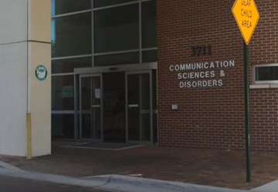Turn right at the traffic circle onto Laurel Drive-building is on the right side look for the sign for 3711 CSD. Parking Directions are on next page.

**Parking at USF CSD Hearing and Speech-Language Clinics**

Please park in the reserved spots marked PSY/CSD in Lots 9A or 46.

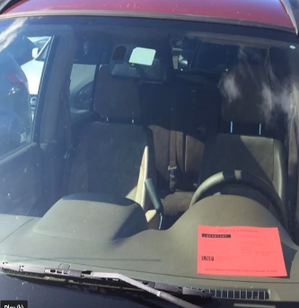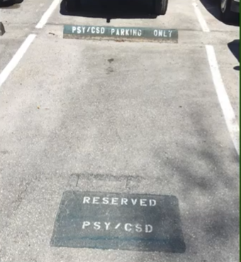***Please display RED clinic parking pass on dashboard.***

Lot 9A

* Lot 9A is located past the building on the Left (assigned reserved parking spaces are closest to the Psychology Building). When you exit your car, you will want to head back to the CSD Building which will be on your left.

Lot 46

* Additional parking is available in lot 46, which is located past the building and playground on the Right. Once you enter the parking lot stay to the right, closest to the playground and continue to keep right. This parking lot has several sections (assigned reserved parking spaces are located at the farthest end from where you entered, back towards Citrus Drive.) When you exit your car, please enter the CSD building from the closest doors and walk down the hallway past the bathrooms and towards the sliding doors.

***The Hearing Clinic is located on the first floor of the Communication Sciences & Disorders Building and The Speech Clinic is located on the second floor.***

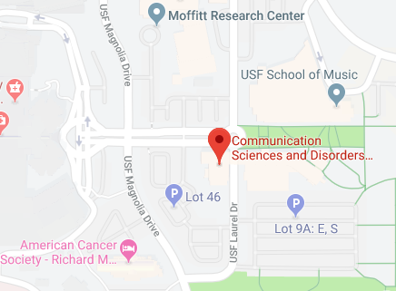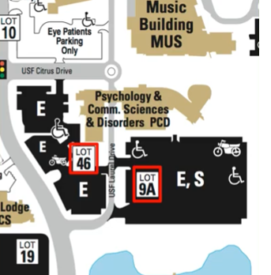

FIND YOURSELF LOST ON CAMPUS?  
Call USF Visitor Services! 813-974-4607

**Red** arrows indicate where reserved spots are located in each parking lot